AI WEATHERWISE

SMART WEATHER MONITORING & AI RECOMMENDATIONS

MINI PROJECT DOCUMENTATION
Submitted By:
Team Leader:
Manasa R.K
Team Members:
KOMATHI M
Gopika D
Ayesha Banu.A
Department:
Artificial Intelligence & Data Science

PROJECT DESCRIPTION
AI WeatherWise is a smart weather monitoring web application that combines current weather information with Artificial Intelligence.
The application provides weather details, AI-generated recommendations, weather summaries, and weather risk assessment.
It also provides secure user authentication and allows users to save frequently used locations.

1. ABSTRACT
AI WeatherWise is a smart weather monitoring web application developed to provide current weather information along with AI-based weather recommendations, summaries, and risk assessment.
The application allows users to register and log in securely, search weather information by city, save frequently used locations, and receive useful AI-generated insights.
The frontend is developed using HTML, CSS, and JavaScript. The backend is developed using Node.js and Express.js. MongoDB is used for database management, while JWT is used for authentication.
Gemini AI is used to generate weather-related insights. The system also provides a weather risk score from 0 to 100, a risk level, and a safety alert based on weather conditions.

2. INTRODUCTION
Weather conditions play an important role in daily life. Temperature, humidity, rain, and other weather conditions can affect travel, outdoor activities, transportation, agriculture, and personal planning.
Traditional weather applications mainly display weather values. Users need to understand these values and decide what action should be taken.
AI WeatherWise improves this process by combining weather information with Artificial Intelligence.
The system analyzes weather conditions and provides simple recommendations, summaries, and risk information.
The main goal is to make weather information easier to understand and more useful for users.

3. PROBLEM STATEMENT
Most weather applications provide raw weather information such as temperature, humidity, and weather condition.
Users may not always understand the impact of these values on their daily activities.
There is a need for a smart weather monitoring application that can:
- Display current weather information.
- Explain weather conditions in simple language.
- Provide AI-based recommendations.
- Identify weather-related risks.
- Provide safety alerts.
- Allow users to save frequently used locations.
- Provide secure user authentication.

4. OBJECTIVES
The main objectives of AI WeatherWise are:
- To provide current weather information for a selected city.
- To provide secure user registration and login.
- To implement JWT-based authentication.
- To generate AI-based weather recommendations.
- To generate simple AI weather summaries.
- To calculate weather risk scores.
- To identify weather risk levels.
- To provide weather safety alerts.
- To allow users to save and manage locations.
- To develop a simple and user-friendly weather monitoring system.

5. SCOPE OF THE PROJECT
The project focuses on providing weather information and intelligent weather insights through a web application.
The system can be used by students, employees, travelers, and general users who need simple weather information for daily planning.
The application can also be extended in the future with advanced prediction and notification features.

6. KEY FEATURES

6.1 USER REGISTRATION
New users can create an account by providing their name, email, and password.

6.2 USER LOGIN
Registered users can log in securely using their email and password.

6.3 JWT AUTHENTICATION
JSON Web Token authentication is used to protect user-specific API requests.

6.4 WEATHER SEARCH
Users can enter a city name and retrieve current weather information.
The system displays:
- City
- Temperature
- Weather Condition
- Humidity

6.5 AI WEATHER RECOMMENDATION
The system generates useful recommendations based on the current weather condition.
For example, during hot weather, the system can recommend staying hydrated, wearing light clothing, and avoiding outdoor activities during peak afternoon hours.

6.6 AI WEATHER SUMMARY
The system converts weather values into a simple natural-language summary.
Example:
“Today’s weather in Chennai is warm and clear with moderate humidity.”

6.7 AI WEATHER RISK ASSESSMENT
The system analyzes temperature, humidity, and weather condition and generates:
- Risk Score
- Risk Level
- AI Alert

6.8 SAVED LOCATIONS
Users can save frequently searched cities.
Users can add, view, update, and delete saved locations.

7. SYSTEM WORKFLOW
The complete workflow of the application is:
User Registration
↓
User Login
↓
JWT Authentication
↓
Enter City Name
↓
Fetch Weather Data
↓
Display Weather Information
↓
Generate AI Recommendation
↓
Generate AI Weather Summary
↓
Generate AI Risk Assessment
↓
Display Risk Score and Alert
↓
Save Location

8. SYSTEM ARCHITECTURE
The system follows a frontend-backend architecture.
FRONTEND
HTML + CSS + JavaScript
↓
REST API REQUEST
↓
BACKEND
Node.js + Express.js
↓
├── Authentication
├── Weather Service
├── Location Service
├── AI Service
↓
MongoDB Database

9. MODULES
The main modules are:
- Authentication Module
- Weather Module
- Location Management Module
- AI Recommendation Module
- AI Summary Module
- AI Risk Assessment Module
- Database Module
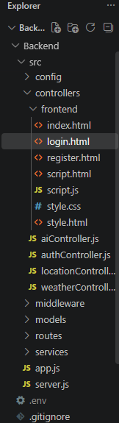
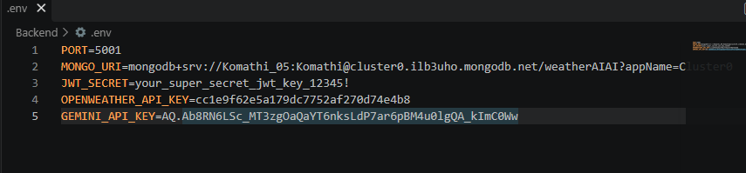

10. TECHNOLOGIES USED

10.1 FRONTEND

HTML
HTML is used to create the structure of the web pages.

CSS
CSS is used to design the user interface and provide styling.

JavaScript
JavaScript is used to implement frontend logic and communicate with backend APIs.

10.2 BACKEND

Node.js
Node.js is used as the JavaScript runtime environment for the backend.

Express.js
Express.js is used to create RESTful APIs and handle backend requests.

10.3 DATABASE

MongoDB
MongoDB is used to store user information and saved-location data.

10.4 AUTHENTICATION

JWT
JSON Web Token is used to authenticate users and protect API routes.

10.5 ARTIFICIAL INTELLIGENCE

Gemini AI
Gemini AI is used to generate weather summaries, recommendations, and risk-related insights.

Fallback Risk Logic
Fallback risk logic is used to provide risk assessment when the AI service is unavailable.

10.6 DEVELOPMENT AND TESTING TOOLS

Visual Studio Code
Used for project development.

Postman
Used to test backend API endpoints.

Git and GitHub
Used for version control and project repository management.

11. MAIN API ENDPOINTS

AUTHENTICATION APIs

POST /api/auth/register
Purpose: Creates a new user account.

POST /api/auth/login
Purpose: Authenticates a user and returns a JWT token.

GET /api/auth/profile
Purpose: Returns the profile of the authenticated user.

WEATHER API

GET /api/weather/
Purpose: Retrieves weather information for the selected city.

LOCATION APIs

POST /api/locations
Purpose: Saves a new location.

GET /api/locations
Purpose: Retrieves saved locations.

PUT /api/locations/
Purpose: Updates an existing saved location.

DELETE /api/locations/
Purpose: Deletes a saved location.

AI APIs

POST /api/ai/weather-summary
Purpose: Generates an AI weather summary.

POST /api/ai/weather-recommendation
Purpose: Generates an AI weather recommendation.

POST /api/ai/weather-risk
Purpose: Generates a weather risk assessment.

12. AI WEATHER RISK ASSESSMENT
AI WeatherWise includes an AI Weather Risk Assessment feature.
The system takes the following inputs:
- Temperature
- Humidity
- Weather Condition
Based on these values, the system generates:
- Risk Score
- Risk Level
- Safety Alert

RISK SCORE RANGE
0 - 100

DEMO RESULT
City: Chennai
Temperature: 35.23°C
Humidity: 52%
Condition: Clear
Risk Score: 40%
Risk Level: Moderate Risk
AI Alert:
Weather conditions require caution. Stay prepared and monitor the weather before outdoor activities.

13. FALLBACK RISK LOGIC
The backend also contains fallback risk calculation logic.
The fallback logic considers:
- High temperature
- Low temperature
- High humidity
- Rain
- Heavy rain
- Thunderstorm or storm conditions
The system calculates a risk score and identifies the corresponding risk level.
The final risk score is limited to a maximum of 100.

14. SAMPLE AI OUTPUT

AI Weather Recommendation
Stay hydrated, wear light cotton clothes, and avoid outdoor activities during peak afternoon hours.

AI Weather Summary
Today’s weather in Chennai is warm and clear with moderate humidity.

15. DATABASE DESIGN
MongoDB is used as the database.

USER DATA
The user information includes:
- Name
- Email
- Password

LOCATION DATA
The saved location information includes:
- City
- Country
- User Reference
The location data is associated with the authenticated user.

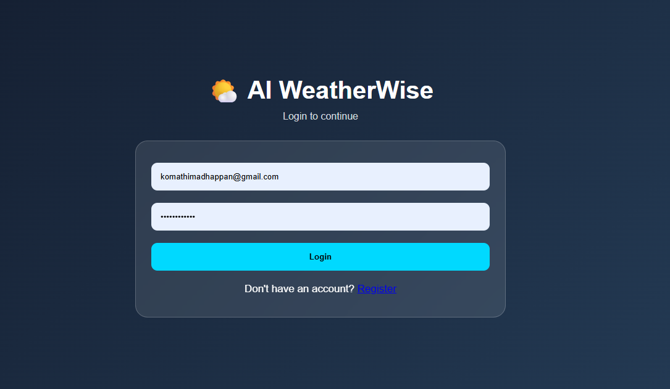
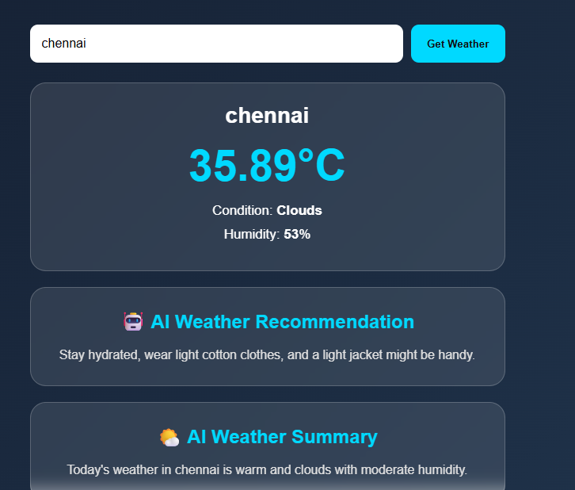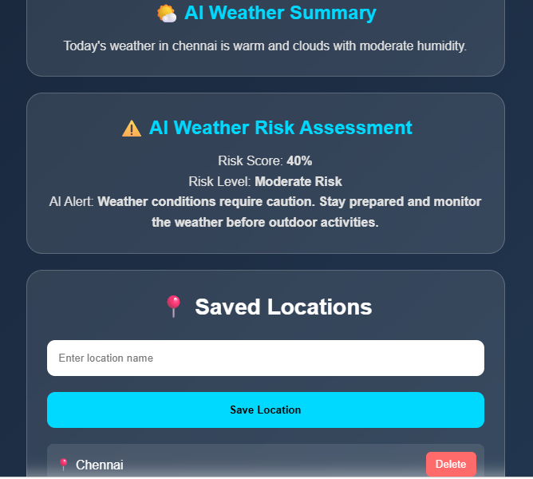

16. SECURITY
The following security features are implemented:
- JWT-based authentication.
- Protected API routes.
- Bearer token authorization.
- Authentication middleware.
- User-specific saved locations.
- CORS configuration.
- Environment variables for sensitive configuration.
- .env file is excluded from GitHub using .gitignore.

17. FRONTEND PAGES

index.html
Main weather dashboard.

login.html
User login page.

register.html
New user registration page.

script.js
Handles weather search, API communication, AI results, saved locations, and logout functionality.

style.css
Provides the styling and visual design of the application.

18. TESTING
The application was tested using Postman and the browser.

TEST RESULTS
Test | Result
User Registration | PASSED
User Login | PASSED
JWT Authentication | PASSED
User Profile | PASSED
Weather Search | PASSED
Create Location | PASSED
Read Location | PASSED
Update Location | PASSED
Delete Location | PASSED
AI Weather Recommendation | PASSED
AI Weather Summary | PASSED
AI Weather Risk Assessment | PASSED
Frontend Integration | PASSED
GitHub Push | PASSED

19. ADVANTAGES
- Simple and user-friendly interface.
- Combines weather monitoring and Artificial Intelligence.
- Provides understandable weather recommendations.
- Provides weather risk assessment.
- Provides safety alerts.
- Secure authentication using JWT.
- Allows users to save frequently used locations.
- Uses RESTful API architecture.
- Uses MongoDB for data management.
- Can be extended with additional AI features.

20. FUTURE ENHANCEMENTS
- Multi-day weather forecasting.
- Weather charts and graphs.
- Historical weather analysis.
- Map-based location selection.
- Personalized AI recommendations.
- Severe weather notifications.
- Mobile application.
- Cloud deployment.
- Advanced machine learning-based weather prediction.
- Voice-based weather assistant.

21. CONCLUSION
AI WeatherWise is a smart weather monitoring web application that combines weather data, Artificial Intelligence, secure authentication, and database technology.
The system provides users with current weather information along with AI-generated recommendations, summaries, and weather risk assessment.
The project demonstrates the practical application of Artificial Intelligence, web development, REST APIs, MongoDB, JWT authentication, and AI services.
The system provides a foundation for developing more advanced intelligent weather monitoring and prediction applications in the future.

21. CONCLUSION
AI WeatherWise is a smart weather monitoring web application that combines weather data, Artificial Intelligence, secure authentication, and database technology.
The system provides users with current weather information along with AI-generated recommendations, summaries, and weather risk assessment.
The project demonstrates the practical application of Artificial Intelligence, web development, REST APIs, MongoDB, JWT authentication, and AI services.
The system provides a foundation for developing more advanced intelligent weather monitoring and prediction applications in the future.

23. PROJECT SUMMARY
Project Title: AI WeatherWise
Subtitle: Smart Weather Monitoring & AI Recommendations
Student: Komathi M
Department: Artificial Intelligence & Data Science
Academic Year: 2026
Frontend: HTML, CSS, JavaScript
Backend: Node.js, Express.js
Database: MongoDB
Authentication: JWT
AI: Gemini AI + Fallback Risk Logic
API Testing: Postman
Development: Visual Studio Code
Version Control: Git and GitHub
Demo video:Backend Demo video

